YEAR 11 |  | Spring
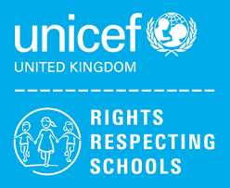 | Rights of the Child | Article 29 (goals of education) Education must develop every child’s personality, talents and abilities to the full. It must encourage the child’s respect for human rights, as well as respect for their parents, their own and other cultures, and the environment.
 | English | 11RS– Step Up Component 2 Reading Fiction.  Functional Skills Level 2 Writing Skills  11GG – Paper 1 Revision
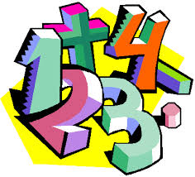 | Maths | 11GG – Number, Algebra, Geometry & Measures, Ratio, Probability, Statistics  11RS – Measures – capacity, temperature and weight, Measures – distance and length
 | Science | ELC: Completion of Science Investigation Portfolios, revision and completion of Topic Assessments  GCSE: Organic Chemistry, Atomic structure, Waves, Chemistry of the atmosphere, Using resources
 | Computing/ICT | 11GG – EdExcel Functional Skills Level 2 exam preparation  11RS – WJEC Entry Pathways Modules – Spreadsheet Software/Database Software/Using Email
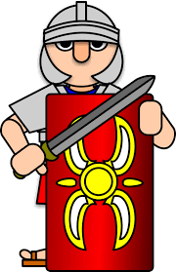 | History | GCSE – Health and Medicine  Site Study: Yorkshire 1066-1100
 | Humanities | Environmental Awareness
 | P.E. | 11RS/11GG – PE – Fitness, replication of movement in Trampolining
 | Duke of Edinburgh | DofE –  Section 2 – Skills – Sports leadership
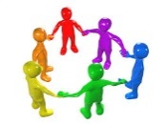 | PHSCE | Topic: Skills for employment, Careers, CV Writing (Personal Statements)
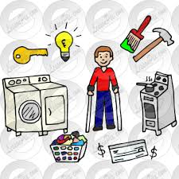 | Independent Living | Food and Drink Preparation
 | ASDAN  Construction | Carpentry  Painting and decorating
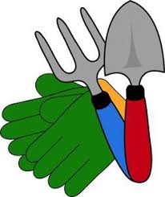 | ASDAN  Gardening | ASDAN Individual Units
 | Travelling Independently | Identifying and using pedestrian crossings  Planning a route

