YEAR 10 |  | Autumn | Spring | Summer
 | Rights of the Child | Article 29 (goals of education) Education must develop every child’s personality, talents and abilities to the full. It must encourage the child’s respect for human rights, as well as respect for their parents, their own and other cultures, and the environment. | Article 29 (goals of education) Education must develop every child’s personality, talents and abilities to the full. It must encourage the child’s respect for human rights, as well as respect for their parents, their own and other cultures, and the environment. | Article 29 (goals of education) Education must develop every child’s personality, talents and abilities to the full. It must encourage the child’s respect for human rights, as well as respect for their parents, their own and other cultures, and the environment.
 | English | Speaking and Listening – Presentation Skills  Paper 1 – Reading  Step Up to English – Component 1 – Speaking and Listening  Step Up to English – Component 1 - Writing | Paper 1 – Reading  Paper 1 – Reading Revision  Step Up to English – Component 1 – Reading  Step Up to English – Component 2 – Speaking and Listening | Paper 1 – Creative Writing  Descriptive Writing  Narrative Writing  Step Up to English – Component 2 – Reading  Step Up to English – Component 2 - Writing
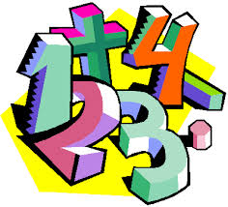 | Maths | WJEC assessments  Number  Data  Shape  Measures  Fractions  Angles  Money  Place value (10RF/10RH)  Addition & subtraction (10RF/10RH)  Multiplication & division (10RF/10RH)  GCSE  Angles  Scale diagrams and bearings  Basic number  Factors and multiples  Basic algebra  Basic fractions  Coordinates and linear graphs  Basic decimals  Rounding  Collecting and representing data  Sequences | WJEC assessments  Number  Data  Shape  Measures  Fractions  Angles  Money  Multiplication & division (10RF/10RH)  Length & perimeter (10RF/10RH)  Fractions, decimals and percentages (10RF/10RH)  Mass & capacity (10RF/10RH)  GCSE  Basic percentages  Perimeter and area  Circumference and area  Real life graphs  Ratio and proportions  Properties of polygons  Equations  Indices  Standard Form | WJEC assessments  Number  Data  Shape  Measures  Fractions (10RF/10RH)  Angles  Money (10RF/10RH)  Time (10RF/10RH)  Shape (10RF/10RH)  Statistics (10RF/10RH)  GCSE  Basic probability  Transformations  Congruence and similarity  2D representations of 3D shapes  Calculating with rectangles  Measures  Statistical measures  Constructions and loci
 | Science | Entry Level  C1 The Human Body – Theory  C1 The Human Body – ESA and TDA investigations  GCSE  Cell Biology and Organisation  Atomic Structure, Periodic Table and Bonding and Structures | Entry Level  C3 Elements, Mixtures and Compounds – Theory  C3 Elements, Mixtures and Compounds – ESA and TDA investigations  GCSE  Energy and Electricity  Infection & Response and Bioenergetics | Entry Level  C5 Energy, Forces and Structures of Matter – Theory  C5 Energy, Forces and Structures of Matter – ESA and TDA investigations  GCSE  Quantitative Chemistry, Chemical Change and Energy Change  Particle Model and Atomic Structure
 | Computing/ICT | 10RH/10RF –Digital Functional Skills @ E3 – Using devices and handling information / Creating and Editing  10SC – Digital Functional Skills @ Level 1 – Using devices and handling information / Creating and Editing | 10RH / 10RF – Digital Functional Skills @ E3 – Using devices and handling information / Creating and Editing  10SC – Digital Functional Skills @ Level 1 – Using devices and handling information / Creating and Editing | 10RH/10RF – Digital Functional Skills @ E3 – Communicating  10SC – Digital Functional Skills @ Level 1 - Communicating
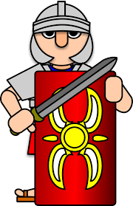 | History | Conflict and Tension  1918-1939 | The Normans  1066-1103 | Democracy and Dictatorship – Germany  1890-1945
 | Humanities | Responding to a Tectonic Event (10RF) (10RH)  Changing population (10RF) | Responding to a Tectonic Event (10RF)  Changing Population (10RF) (10RH)  People and Protest (10RF) | Responding to a Tectonic Event (10RF)  People and Protest (10RF) (10RH)
 | P.E. | Dodgeball  Basketball | Fitness  Trampolining | Athletics  Rounders  Cycling / Walking
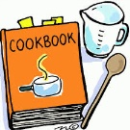 | Food Technology | Home cooking skills  Planning a two course meal  Methods of Cookery | Home cooking skills  Preparing and cooking a two course meal  Healthy Eating | Home cooking skills  Economising & Shopping  Passing on information
 | Creative Media | Ceramics  LO1 Record experiences  LO2 Evidence of Ideas | Ceramics  LO3 Evidence of an appropriate ceramic outcome | Film Genres  LO1 How films are grouped in Genres  LO2 Key Conventions  LO3 Produce an idea for a new film
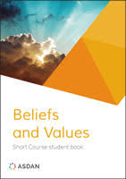 | Beliefs and Values | Values, Beliefs and Decision Making | Crime and Punishment | Environment
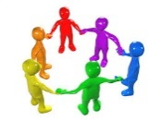 | RSE & Health Education | Health & Wellbeing  Mental health and ill health, tackling stigma, building resilience  RSE  The benefits of regular self-examination and screening | Relationships  Managing change, grief and bereavement  Managing relationship challenges including break ups  Relationship myths and expectations  Careers Lesson/s  Raising aspirations and stereotyping (1 lesson)  RSE  The facts about reproductive health including fertility and the potential impact of lifestyle on fertility for men and women and the menopause  Careers Lesson/s  Employer Talk (1 lesson) | Relationships  Personal values and assertive communication in relationships  Tackling domestic abuse and forced marriage  RSE  Characteristics and legal status of other types of long-term relationships  Healthy relationships and consent  Risks of STIs, sexting and pornography  Careers Lesson/s  What makes you tick – personality test and job values (1 lesson)
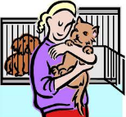 | Animal Care | Animal Investigation / Safety Around Animals  Safety Around Animals / Looking after Animals | Looking After Animals / Animals in Trouble  Looking After Animals / Animals and The Law | Animals and The Law / Careers in Working with Animals
 | DofE: Bronze Award | Taking part in team sports | Learning a new skill  (Camp craft + Navigation skills) | Volunteering / Preparing for the expedition
 | Preparation for Work | Construction  General Construction Operations  Bricklaying | Construction  Carpentry  Painting and Decorating | Construction  Health and Safety  Careers in Construction
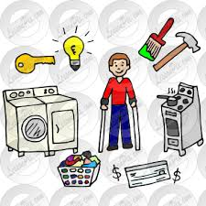 | Independent Living | Looking After Yourself and Your Home (Group 1)  Food and Drink Preparation (Group 1) | Household Cleaning (Group 1)  Looking After Yourself and Your Home (Group 2) | Food and Drink Preparation (Group 2)  Household Cleaning (Group 2)
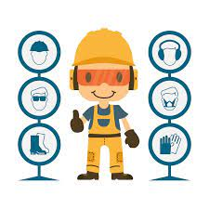 | Preparation for Work | Health & Safety  Designing | Designing  Making | Making  Evaluating

