 | Literacy/  Numeracy  Time  9:00 – 9:30 | Lesson 1  9:30 – 10:20 | 8CL Timetable 2025-2026  Break  10:20 -10:35 | Lesson 2  10:35 – 11:30 | Lesson 3  11:30 – 12:20 | Lunch  12:20 – 12:55 | Lesson 4  12:55 – 1:20 | Lesson 5  1:20 – 2:10 | Lesson 6  2:10 – 3:00
Monday |   Hall | 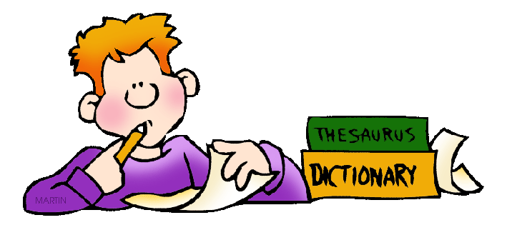  English  Rm 17 |  | 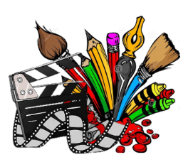  Creative Studies  Rm 5/PA | Creative Studies  Rm 5/PA |  | 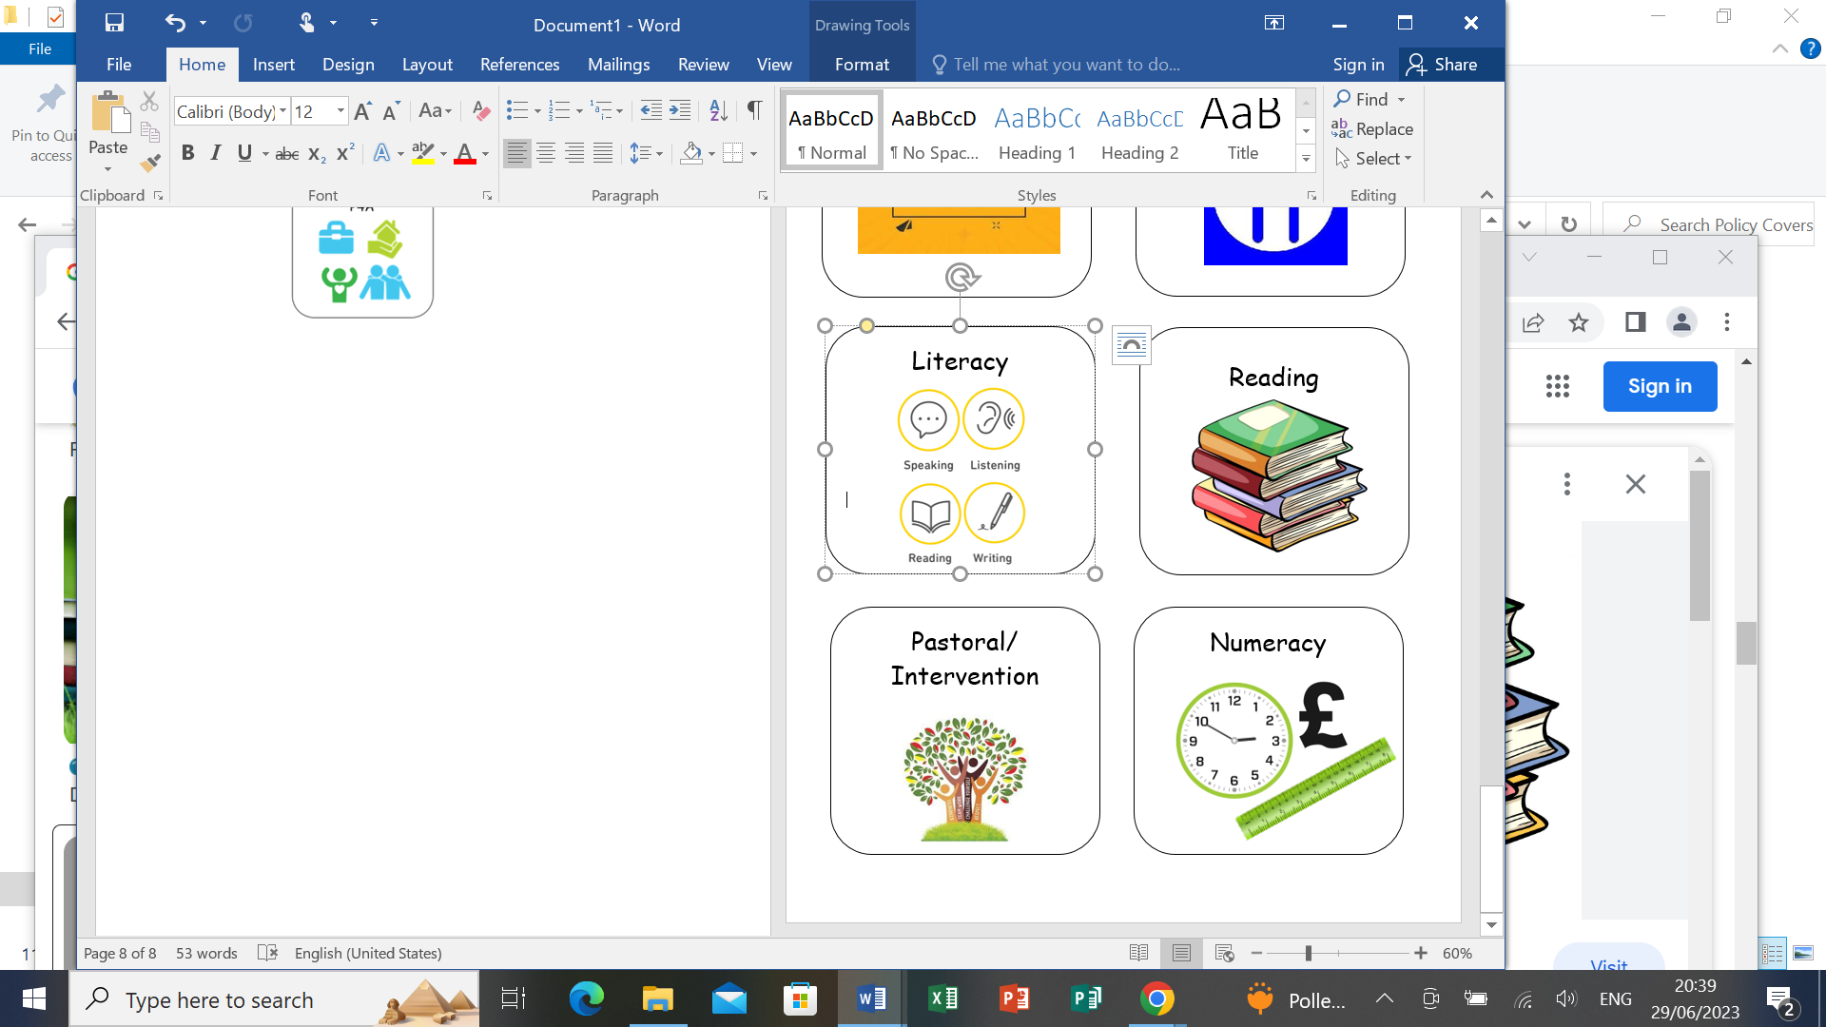    Numeracy |   Maths  Rm 17 |   Science  Rm 17
Tuesday |   Guided  Reading |   Wider World  Rm 2/3/17 |  | Wider World  Rm 2/3/17 | English  Rm 17 |  |   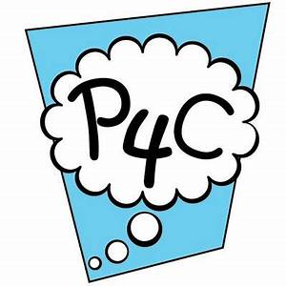  British Values  /Current affairs | 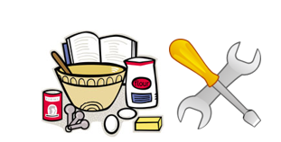  FT/DT  Rm 8/9 | FT/DT  Rm 8/9
Wednesday |   Numeracy | 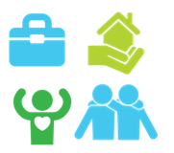  P4A  Rm 17 |  | P4A  Rm 17 | P4A  Rm 17 |  | Literacy |   Beliefs & Values  Rm 17 | Maths  Rm 17
Thursday | Literacy |   Practical Learning  Rm 17 |  | Practical Learning  Rm 17 | Practical Learning  Rm 17 |  | Numeracy |   P.E  Hall |   I.C.T  Rm 6
Friday |   Pastoral | English  Rm 17 |  |   P.E  Hall |   Maths  Rm 17 |  | Pastoral/Credits | Science  Rm 17 |   Reward Time

