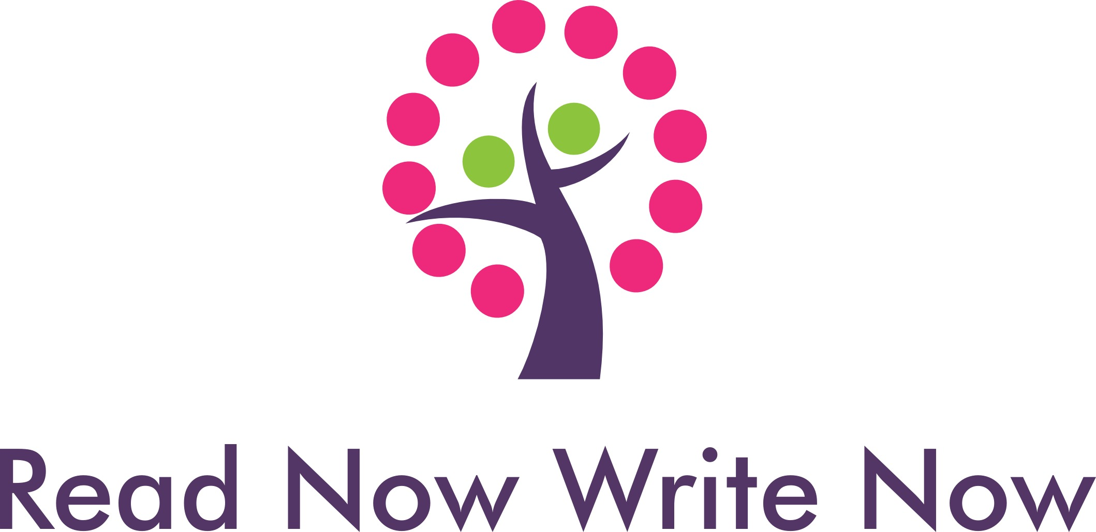

Creative Director: Charlie Lea

Email: [Charles@readnowwritenow.org.uk](mailto:Charles@readnowwritenow.org.uk)

To Parents and Carers

June 2023

Good afternoon

**Got Any ID? Free Creative Writing Workshops for Young People aged 12-18 on Identity and Individuality**

My name is Charlie and I am the creative director of literary arts organisation Read Now Write Now.

Over the summer holidays we will be delivering free creative writing courses for young people aged between 12 and 18 years about identity and individuality. These courses will take place in local libraries and on Zoom and are funded by Arts Council England with support from Wirral, Halton and Cheshire West & Chester Library services.

During inclusive and positive group workshops young people will be able to express their own ideas and experiences looking at themes including diversity and what inspires and interests them.

Using writing devices and techniques plus a selection of relevant literature, they will be guided to write a short story which can be included into a published anthology and also made available online.  There will also be a book launch at Storyhouse, Chester, in the autumn, where they will have the opportunity, if they wish, to read their story to an audience of young people.

To join, simply choose one of the courses:

**Library courses**

Winsford Library, Cheshire Monday 24th July to Thursday 27th July 2pm to 3.30pm

Frodsham Library, Cheshire Saturday 12th August 11am to 12.30pm for 4 weeks

Bebington Library, Wirral Monday 14th to Thursday 17th August 2.15pm to 3.45pm

Widnes Library Monday 21st to Thursday 24th August 11am to 12.30pm

Storyhouse, Chester Monday 28th to Thursday 31st August 2pm to 3.30pm

**Zoom courses**

Saturday afternoons from 29th July to 19th August 2pm to 3.30pm

Monday 14th August to Thursday 17th August 11am to 12.30pm

Monday 21st August to Thursday 24th August 6pm to 7.30pm

Monday 28th August to Thursday 31st August 11am to 12.30pm

And book on via Eventbrite <https://tinyurl.com/4ea6cs88>

Food will also be provided for participants in some of the library sessions. Please note that I will deliver all the sessions and hold an enhanced DBS certificate and public liability insurance.

Best wishes

**Charlie Lea**