 | Literacy/  Numeracy  Time  9:00 – 9:30 | Lesson 1  9:30 – 10:20 | 8AC Timetable 2025-2026  Break  10:20 -10:35 | Lesson 2  10:35 – 11:30 | Lesson 3  11:30 – 12:20 | Lunch  12:20 – 12:55 | Lesson 4  12:55 – 1:20 | Lesson 5  1:20 – 2:10 | Lesson 6  2:10 – 3:00
Monday |   Hall | 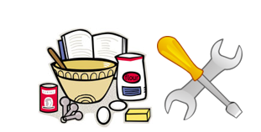  DT/FT  Room 8/9 |  | DT/FT  Room 8/9 |   English  Room 2 |  | 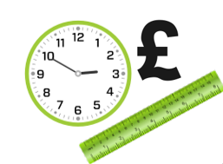    Numeracy |   Maths  Room 2 |   Science  Room 2
Tuesday | Guided Reading  Room 2 |   Wider World  Room 2/3/17 |  | Wider World  Room 2/3/17 |   PE  Hall |  |   British Values/  Current affairs |   Beliefs and Values  Room 3 | Maths  Room 2
Wednesday |   Numeracy  Room 2 | English  Room 2 |  | PE  Hall | Maths  Room 2 |  |   Literacy | Science  Room 2 |   ICT  ICT Room
Thursday | Literacy  Room 2 |   P4A  Room 2 |  |   P4A  Room 2 | P4A  Room 2 |  | Numeracy |   Creative Studies  Room 5/PA | Creative Studies  Room 5/PA
Friday |   Pastoral  Room 2 |   Practical  Learning |  |   Practical  Learning | Practical Learning |  |   Pastoral  Credits | English  Room 2 |   Reward Time

