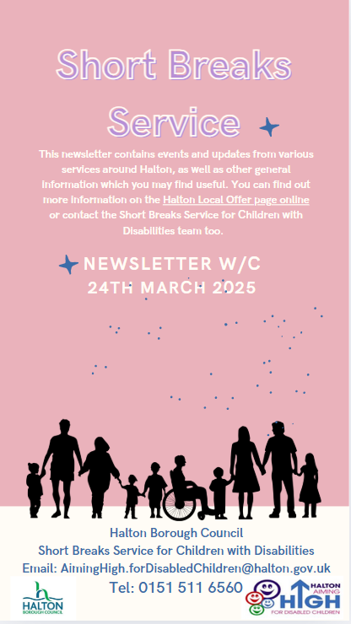

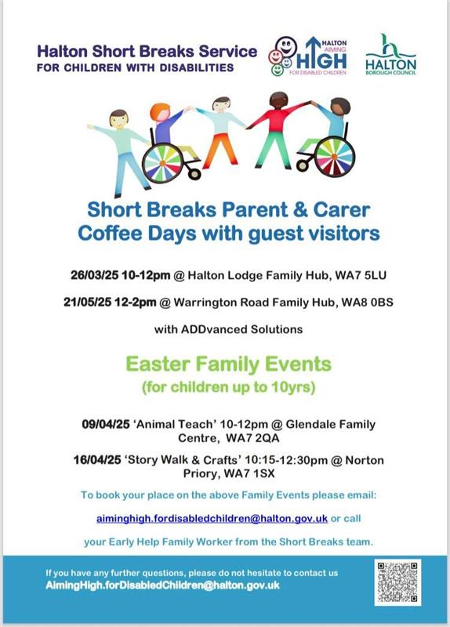


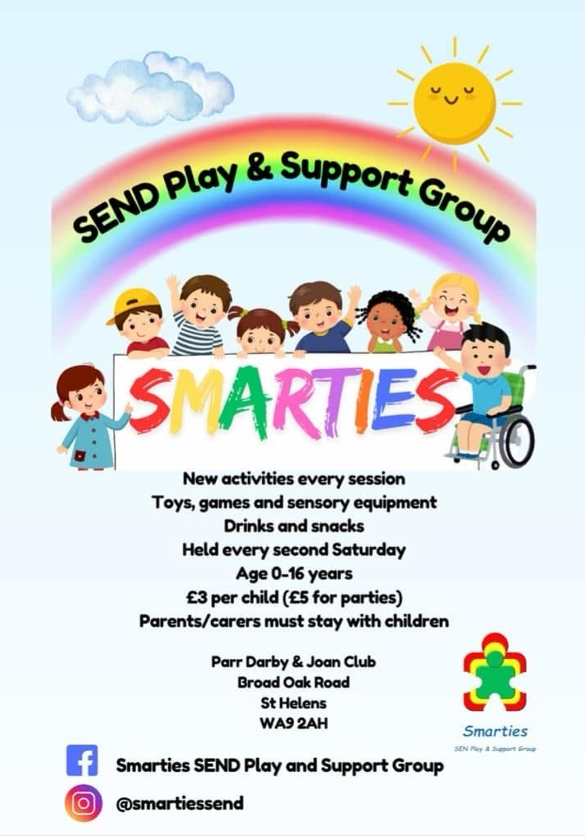
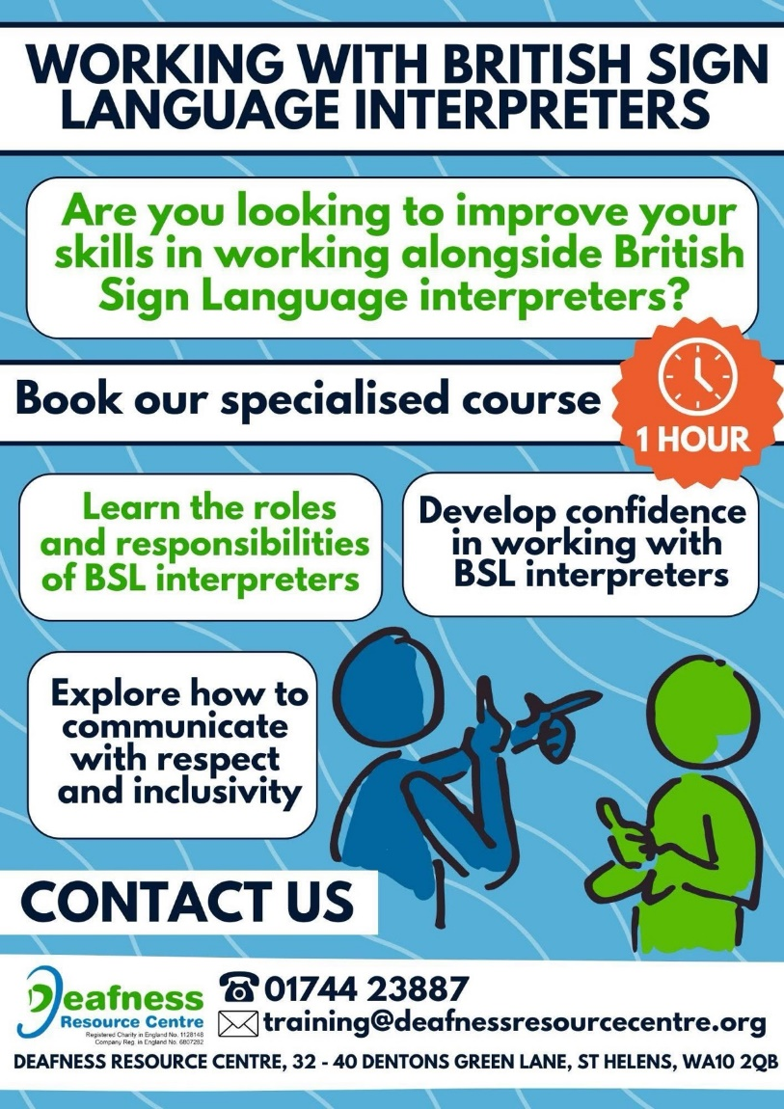

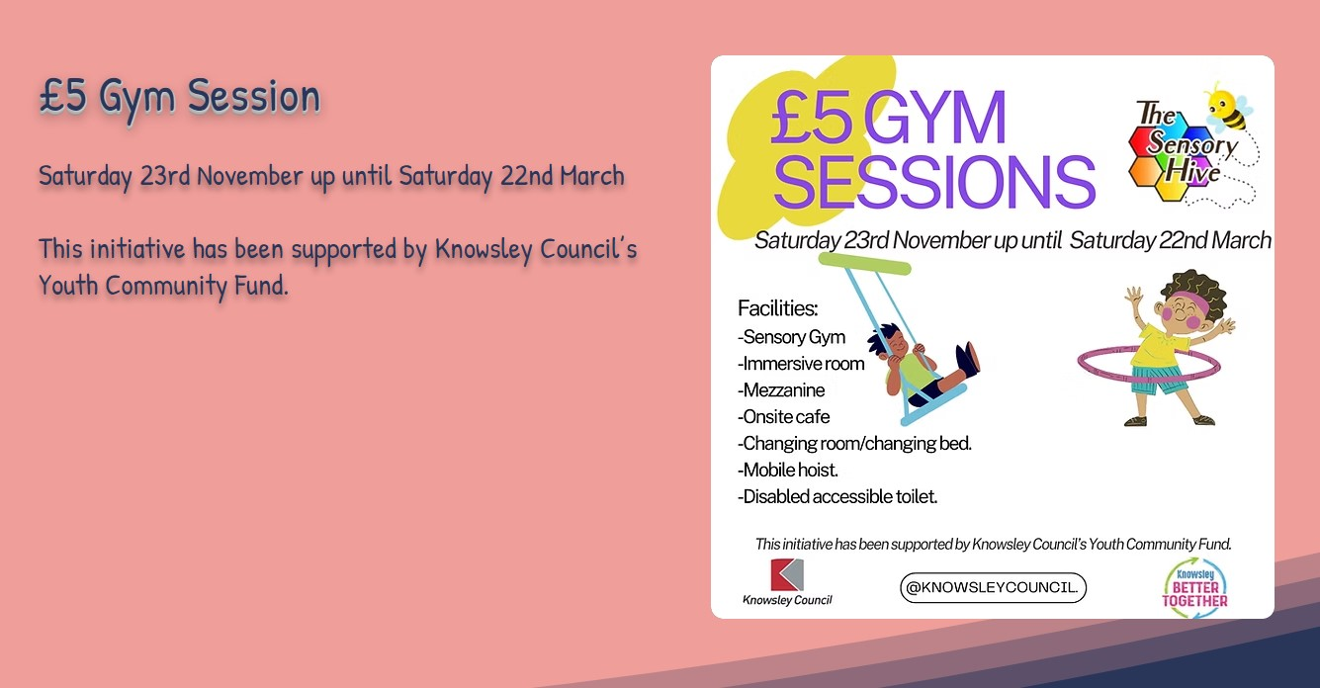
Every year we host two camps for up to 30 children aged 9-15 at each camp. At our camp the children benefit from the independence it offers them. For many, this is the only time they spend away from home all year.
It will run from the 16th-23rd August.
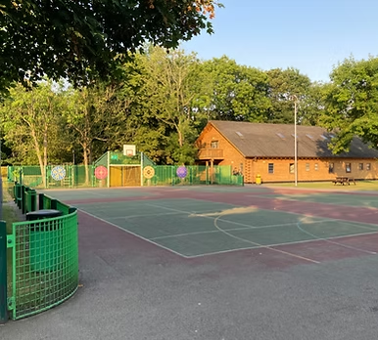
To apply, please visit
https://www.heswallcamp.org.uk/
or message Sophie.rice@heswallcamp.org.uk for more information

Heswall Disabled Children’s Holiday Fund have been hosting free holidays for disabled children since 1962We are driven by a desire to provide opportunities for those children that might not otherwise be available to them, and to provide respite to their families

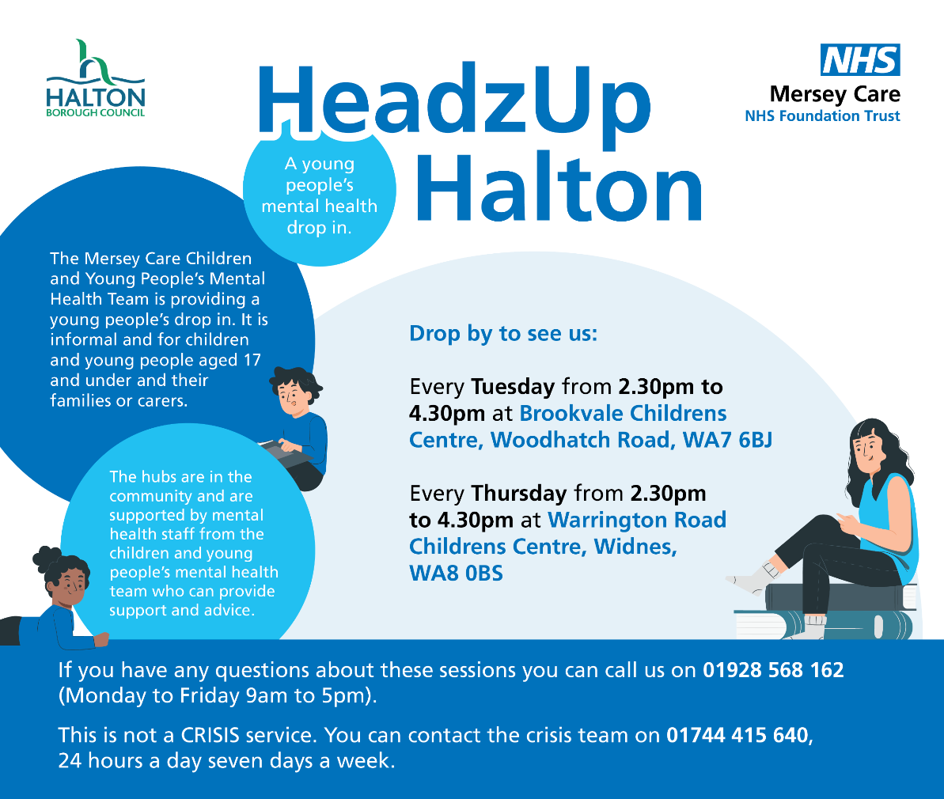
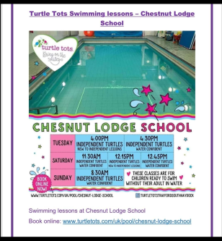

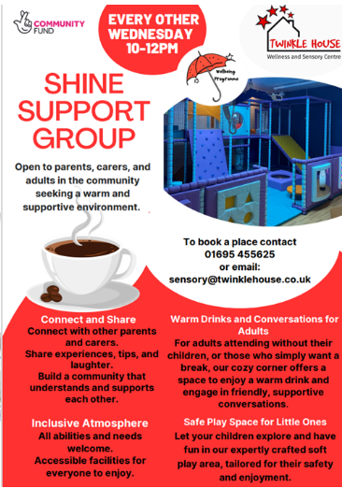
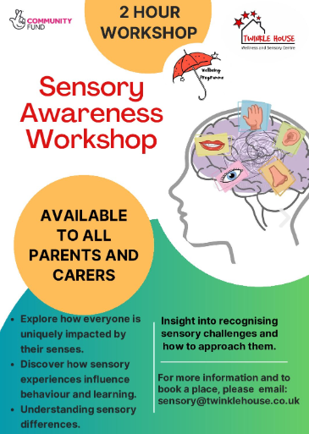
Twinkle House is a fully inclusive wellness and sensory centre that welcomes families, children, young people and adults. Our facilities are accessible to all.
Seeing is believing and we are very proud of our facilities and programmes. We strongly recommend anyone to get in touch and see what we have to offer.
We have a Sensory/Soft Play Room, Immersive Room, Hydrotherapy Pool and Studio which are all available to hire. These are accessible for all ages and abilities.
Based in Skelmersdale, West Lancashire we welcome visitors from all our surrounding areas and districts.
Our aim is to improve the health and wellness in the North West.



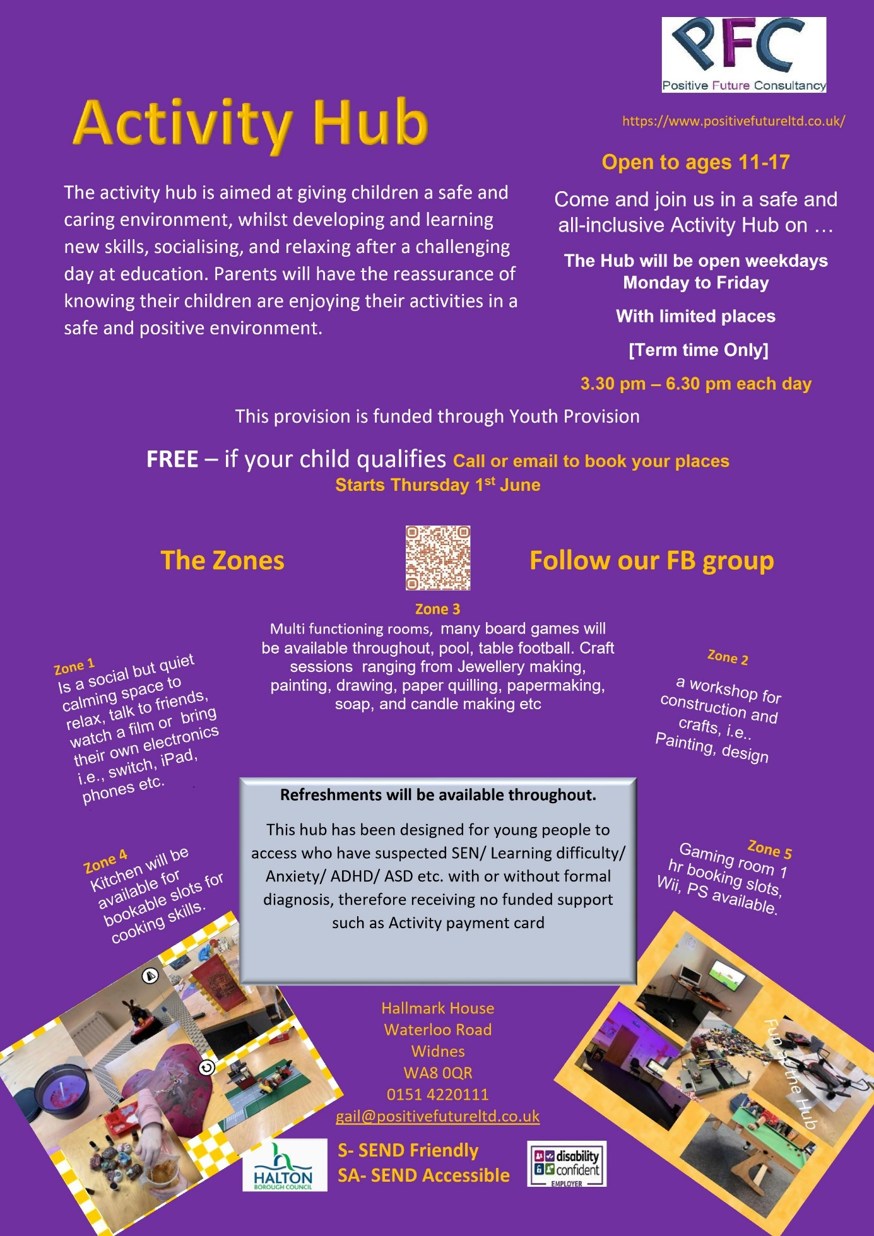



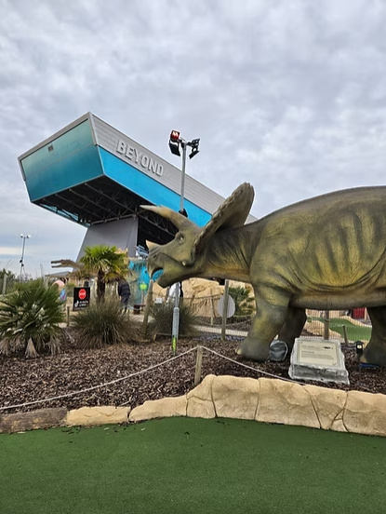
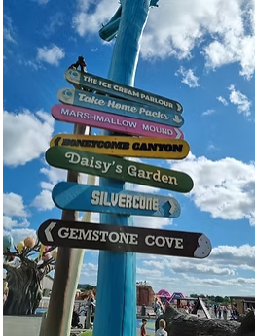
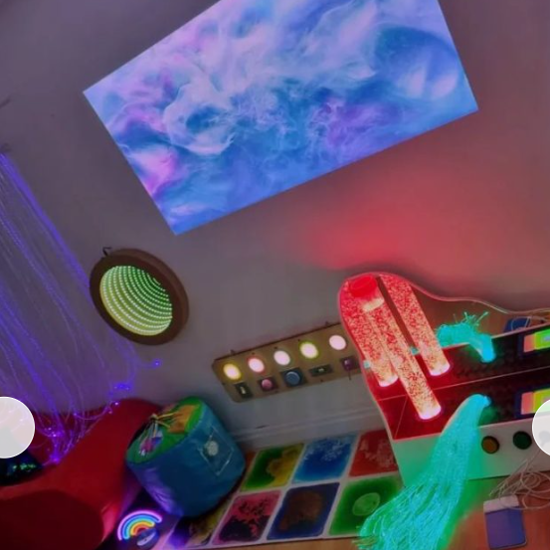
Dino Falls Adventure Golf Manchester
Our Autism-Friendly sessions happen the first Tuesday of each month from 5.30pm to 7.30pm.
Our Autism Friendly sessions ensure a more comfortable and quieter experience for customers.
For more info visit - Autism friendly sessions — Dino Falls Adventure Golf
SEN Sessions at The Ice Cream Farm Chester
Inclusive play is at the heart of The Ice Cream Farm, and we’re proud
to offer dedicated sessions for children who enjoy a quieter, calmer environment.
The Ice Cream Farm’s SEN Sessions take place every month on a weekend morning, with the option to stay afterwards. Parents and carers can expect: limited numbers, hand driers and music turned off, ear defenders available on request, indoor and outdoor attractions open (weather dependent), and sensory toys on sale at The Impulse Emporium for a treat.
To book a sessions visit - SEN Sessions - The Ice Cream Farm
All Thrive - A Multi Sensory Play Space
All Thrive, a multi-sensory, inclusive play space designed for you and your child to embark on a journey of exploration and fun while engaging all the senses!
This inviting venue offers a diverse array of amazingly planned facilities, sessions, activities, and events in a serene and welcoming environment. The team, led by an experienced SEND teacher, is dedicated to ensuring an inclusive and supportive experience for all - All Thrive: A Multi Sensory Play Space - Book Tickets Now

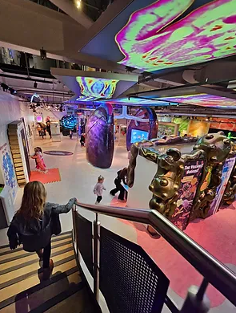
Eureka! Science + Discovery
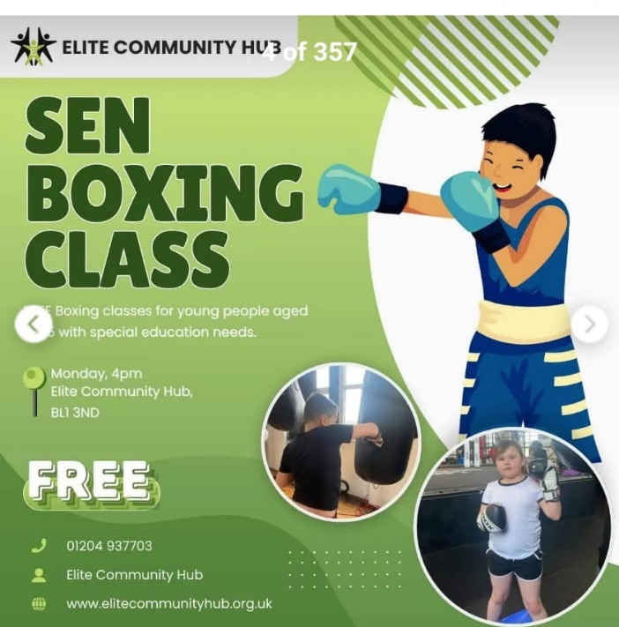

A relaxed day for disabled visitors and their familiesLow visitor numbers:
We’ve heavily restricted ticket availability on these days, so our galleries will be much less busy than usual. We want these days to work around you! Which is why – although we do ask you to select an arrival time – we are flexible if you happen to get here a little earlier or later than your slot.
Chill Out Room:
Need some time out away from the main museum? Just ask any of our Enablers for access to our Chill Out Room.
You can borrow a pair of ear defenders for free from our Information Desk (by the admissions tills) – subject to availability
Our whole team are trained in disability awareness, and we really want you all to have a great day out. Just ask us if there’s anything we can do to support you 🙂All visitors must pre-book, even if you are an existing annual pass holder. There will be a very limited number of tickets available on this day!

Planned SENdays in 2025:
23rd March
22nd June
25th July
21st Sept
16th Nov
7th Dec

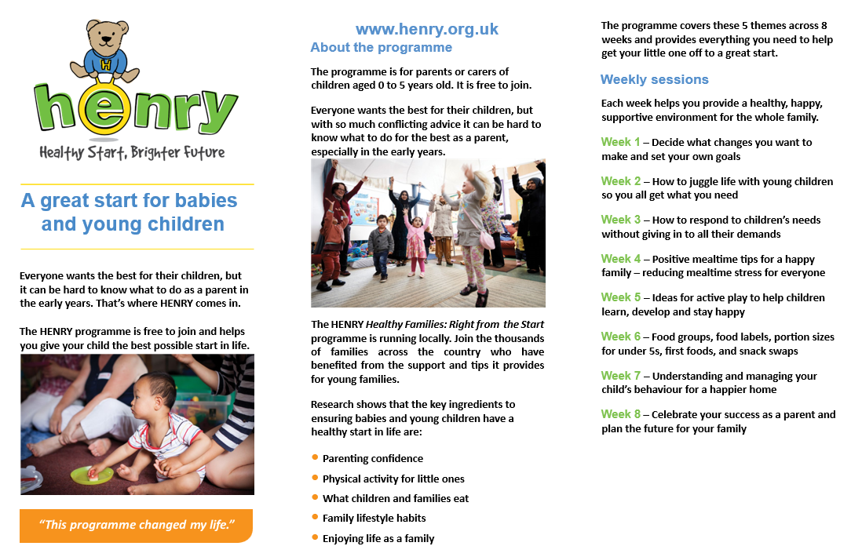


USE CODE TOGETHER


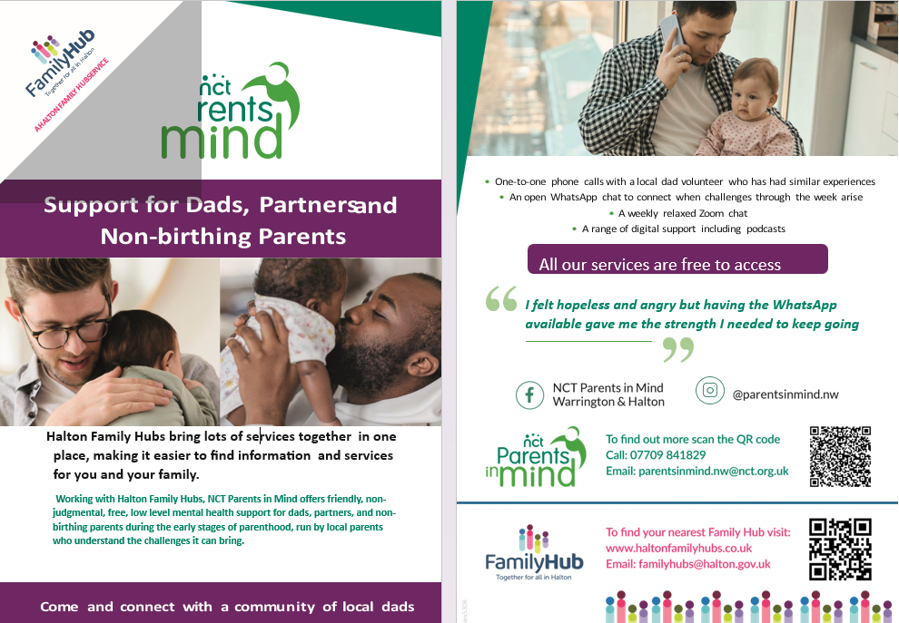

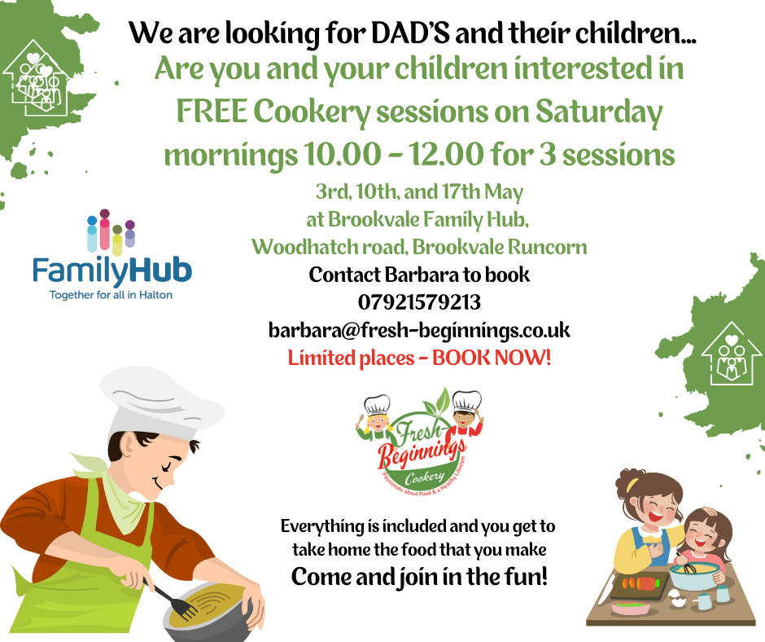
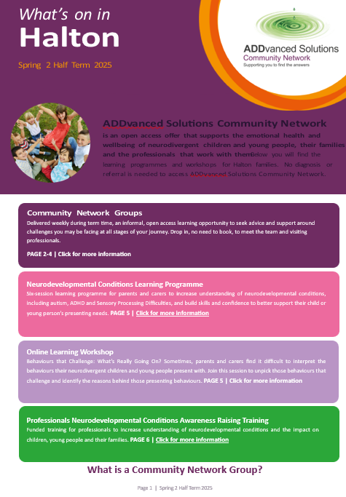

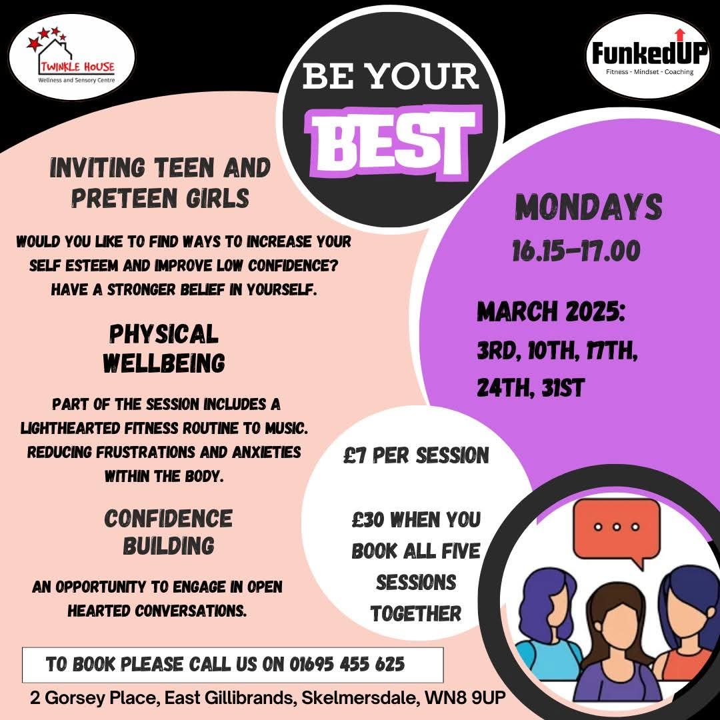

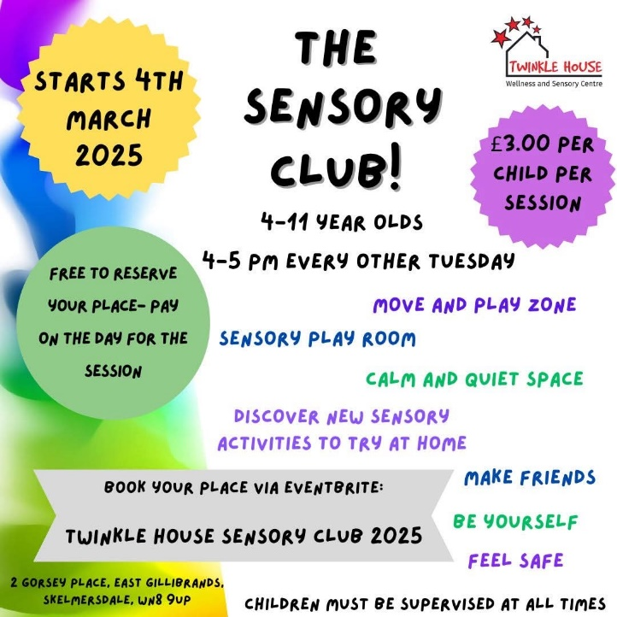
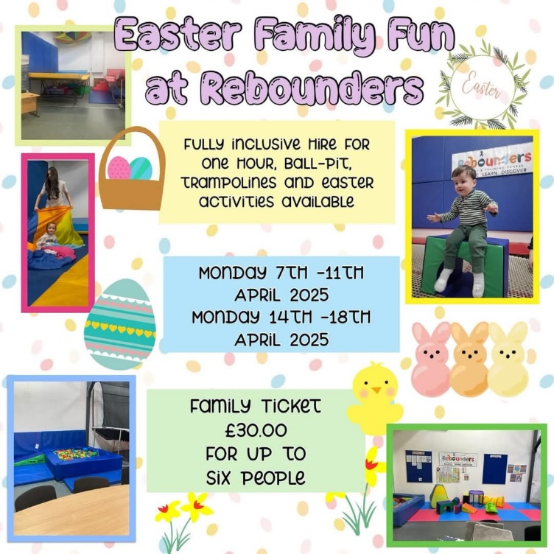

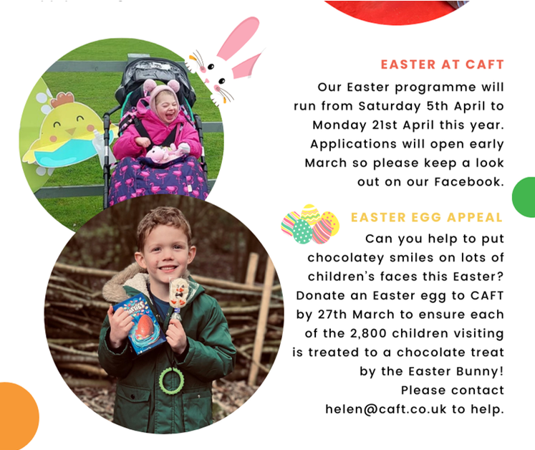
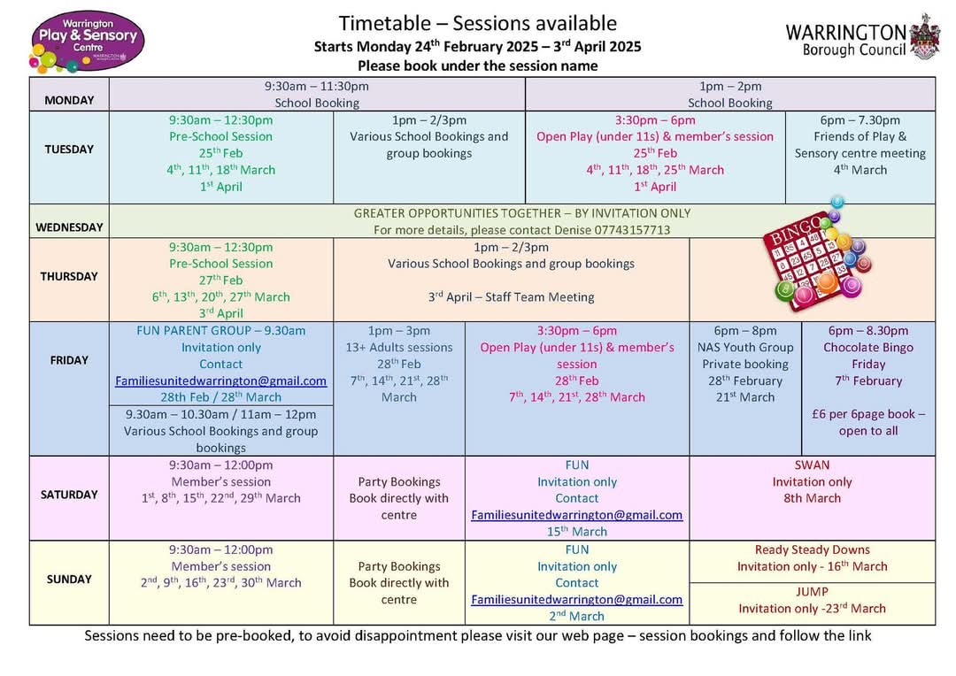
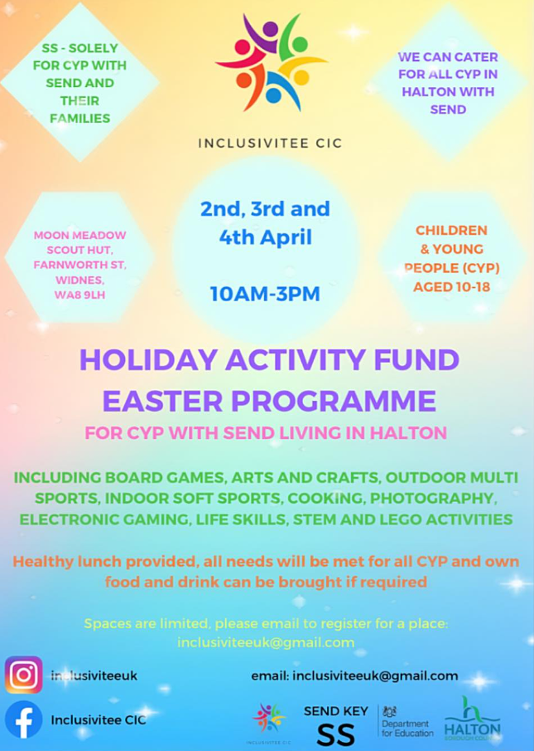

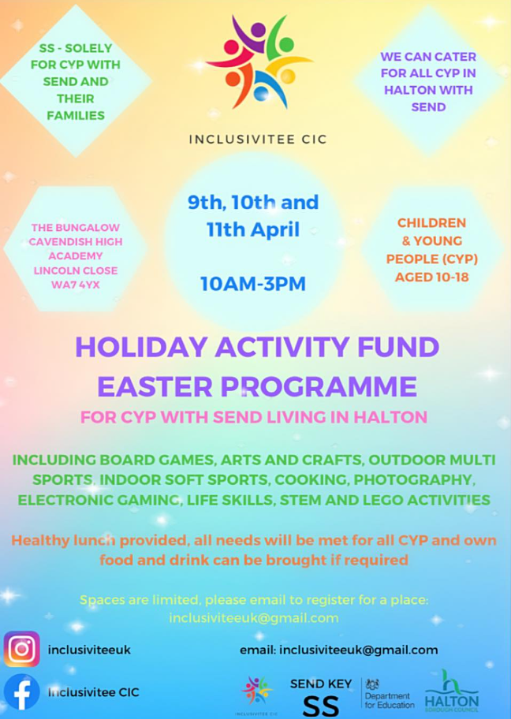
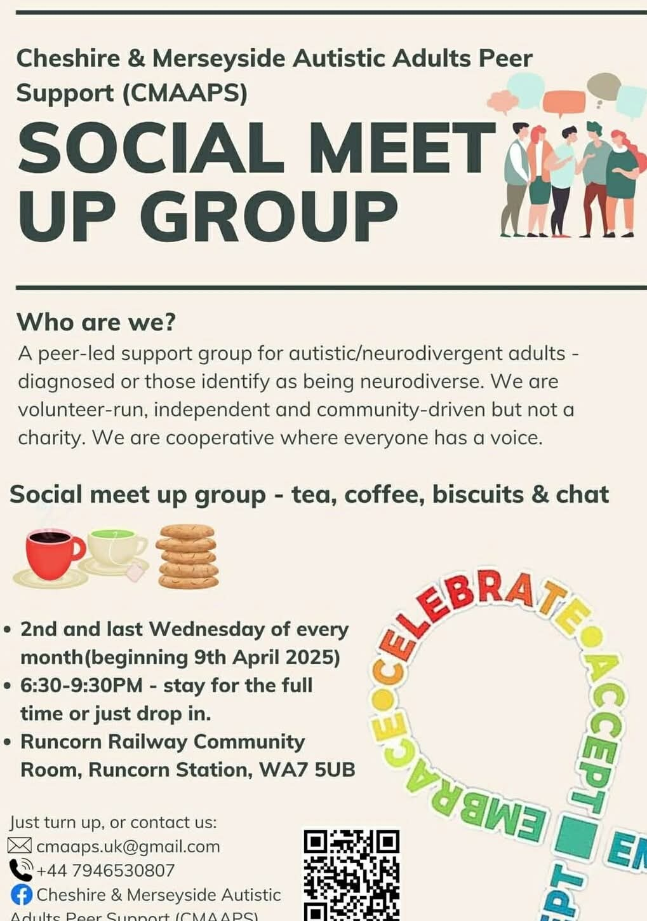

This newsletter provides general information and resources for parents and carers of young people with SEND, and for professionals who support them. Please note, while we take every care to ensure the information we share is accurate the information provided is not a direct recommendation from the Short Breaks Service and we recommend that you complete your own research about the information and events we signpost.

We recognise that not all the information in this newsletter will be relevant to everyone included on the mailing list. If there is some specific information you would like to see more of, or information from a certain service that you’d like to share please let the Short Breaks Service know and we will try to include it next time. If you do not wish to continue receiving this newsletter, please let us know by contacting us at the email address or phone number below.

Halton Borough Council
Short Breaks Service for Children with Disabilities
Email: AimingHigh.forDisabledChildren@halton.gov.uk
Tel: 0151 511 6560

