YEAR 13 |  | Autumn
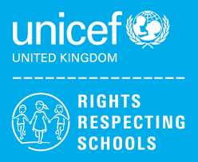 | Rights of the Child | Article 29 (goals of education) Education must develop every child’s personality, talents and abilities to the full. It must encourage the child’s respect for human rights, as well as respect for their parents, their own and other cultures, and the environment.
 | English | 6th Form (U) – Functional Skills Level 2 – Spoken Language Skills & Reading Skills  6th Form (L) - Functional Skills Level 1 – Spoken Language Skills & Reading Skills
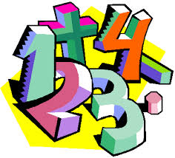 | Maths | Level 1 – Maths skills qualification – a selection of modules including Handling Data  Entry 3 – Ascentis Maths skills qualification – a selection of modules including addition & subtractions skills, multiplying whole numbers
 | Computing/ICT | WJEC ICT Entry Pathways E3 Certificate – Desktop Publishing Software/Using Email
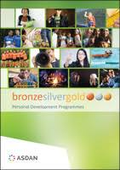 | CoPE/YAS | Developing and demonstrating a range of personal skills by completing a choice of modules from the following:  Communication; Citizenship and Community; Sport and Leisure; Independent Living; The Environment; Vocational Preparation; Health and Fitness; Work Related Learning and Enterprise; Science and Technology; International Links; Expressive Arts; Beliefs and Values (RE)
 | Employability Level 1 Certificate | Health, Safety and First Aid at Work
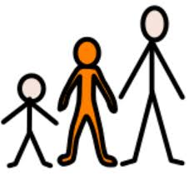 | Preparing for Adulthood | Independent Living – Personal Finance / Work Experience
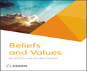 | Beliefs and Values | Crime and Punishment
 | Vocational Core | Level 1 – Developing a Personal Progression Plan
 | Vocational Options  Entry 3 / Level 1 | Students will complete one vocational area each term from the following:  Gardening, Animal Care, Catering
 | Sport | Cycling/Gym workouts

