YEAR 10 |  | Autumn | Spring | Summer
 | Rights of the Child | Article 29 (goals of education) Education must develop every child’s personality, talents and abilities to the full. It must encourage the child’s respect for human rights, as well as respect for their parents, their own and other cultures, and the environment. | Article 29 (goals of education) Education must develop every child’s personality, talents and abilities to the full. It must encourage the child’s respect for human rights, as well as respect for their parents, their own and other cultures, and the environment. | Article 29 (goals of education) Education must develop every child’s personality, talents and abilities to the full. It must encourage the child’s respect for human rights, as well as respect for their parents, their own and other cultures, and the environment.
 | English | Speaking and Listening – Presentation Skills  Paper 1 – Reading  Step Up to English – Component 1 – Speaking and Listening  Step Up to English – Component 1 - Reading | Paper 1 – Reading  Paper 1 – Reading Revision  Step Up to English – Component 1 – Writing  Step Up to English – Component 2 – Speaking and Listening | Paper 1 – Creative Writing  Descriptive Writing  Narrative Writing  Step Up to English – Component 2 – Reading  Step Up to English – Component 2 - Writing
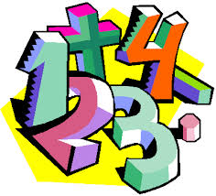 | Maths | WJEC assessments  Number  Data  Shape  Measures  Fractions  Angles  Money  Place value  Addition & subtraction  Multiplication & division  GCSE  Rounding  Pythagoras  2D representation of 3D shapes  Standard form  Calculating with percentages  Measures  Statistical measures  Indices  Constructions and loci | WJEC assessments  Number  Data  Shape  Measures  Fractions  Angles  Money  Multiplication & division  Length & perimeter  Fractions, decimals and percentages  Mass & capacity  GCSE  Algebra recap and extension  Congruence and similarity  Trigonometry  Perimeter and area  Graphs recap and extension  Circumference and area | WJEC assessments  Number  Data  Shape  Measures  Fractions  Angles  Money  Time  Statistics  GCSE  Simultaneous equations  Properties of polygons  Real life graphs  Review of basic probability  Probability
 | Science | Entry Level  C1 The Human Body – Theory  C1 The Human Body – ESA and TDA investigations  GCSE  Cell Biology and Organisation  Atomic Structure, Periodic Table and Bonding and Structures | Entry Level  C3 Elements, Mixtures and Compounds – Theory  C3 Elements, Mixtures and Compounds – ESA and TDA investigations  GCSE  Energy and Electricity  Infection & Response and Bioenergetics | Entry Level  C5 Energy, Forces and Structures of Matter – Theory  C5 Energy, Forces and Structures of Matter – ESA and TDA investigations  GCSE  Quantitative Chemistry, Chemical Change and Energy Change  Particle Model and Atomic Structure
 | Computing/ICT | 10AK – E3 Certificate – Word Processing Software  10GG – Level 1 Certificate – Word Processing Software  10AK – E3 Certificate – Presentation Software  10GG – Level 1 Certificate – Word Processing Software / Presentation Software | 10AK – E3 Certificate – Spreadsheet Software  10GG – Level 1 Certificate – Presentation Software  10AK – E3 Certificate – Spreadsheet Software / Database Software  10GG – Level 1 Certificate – Presentation Software / Spreadsheet Software | 10AK – E3 Certificate – Database Software  10GG – Level 1 Certificate – Spreadsheet Software  10AK – E3 Certificate – Desktop Publishing Software  10GG – Level 1 Certificate – Spreadsheet Software
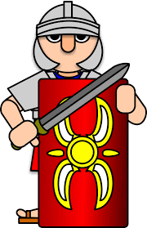 | History | Conflict and Tension  1918-1939 | The Normans  1066-1103 | Democracy and Dictatorship – Germany  1890-1945
 | Humanities | Responding to a Tectonic Event | Changing Population | Changing Population  Preparing portfolios for assessment  Working as part of a group
 | P.E. | Dodgeball  Basketball | Trampolining  Fitness/Cricket | Rounders  Athletics  Tag Rugby
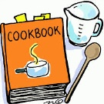 | Food Tech | Home cooking skills  Planning a two course meal  Methods of Cookery | Home cooking skills  Preparing and cooking a two course meal  Healthy Eating | Home cooking skills  Economising & Shopping  Passing on information
 | Creative Media | Ceramics  LO1 Record experiences  LO2 Evidence of Ideas | Ceramics  LO3 Evidence of an appropriate ceramic outcome | Film Genres  LO1 How films are grouped in Genres  LO2 Key Conventions  LO3 Produce an idea for a new film
 | RE | What do we mean by religion and world views? (Contentious issues)  Judaism  How do Jewish holy days remind adherents of their faith? | Christianity: Jesus  Faith and Justice – How should we treat our ‘neighbours’?  Islam  What does belonging mean to a young Muslim in the UK? | Christianity: Church  What is the Church?  Hindu Dharma  What might Hindus learn through celebrating festivals?
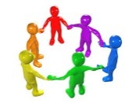 | PHSCE | Health & Wellbeing  Mental health and ill health, tackling stigma, building resilience  RSE  The benefits of regular self-examination and screening | Relationships  Managing change, grief and bereavement  Managing relationship challenges including break ups  Relationship myths and expectations  Careers Lesson/s  Raising aspirations and stereotyping (1 lesson)  RSE  The facts about reproductive health including fertility and the potential impact of lifestyle on fertility for men and women and the menopause  Careers Lesson/s  Employer Talk (1 lesson) | Relationships  Personal values and assertive communication in relationships  Tackling domestic abuse and forced marriage  RSE  Characteristics and legal status of other types of long-term relationships  Healthy relationships and consent  Risks of STIs, sexting and pornography  Careers Lesson/s  What makes you tick – personality test and job values (1 lesson)
 | Animal Care | Animal Investigations | Safety around animals | Animals in Trouble
 | DofE: Bronze Award | Taking part in team sports | Learning a new skill  (Camp craft + Navigation skills) | Volunteering / Preparing for the expedition
 | Preparation for Work | Construction  General Construction Operations  Bricklaying | Construction  Carpentry  Painting and Decorating | Construction  Health and Safety  Careers in Construction
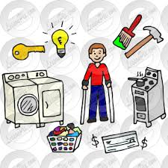 | Independent Living | Looking After Yourself and Your Home (Group 1)  Food and Drink Preparation (Group 1) | Household Cleaning (Group 1)  Looking After Yourself and Your Home (Group 2) | Food and Drink Preparation (Group 2)  Household Cleaning (Group 2)
 | Preparation for Work | P4W  Health & Safety  Designing | P4W  Designing  Making | P4W  Making  Evaluating

