10RH | 9:00 – 9:30 | Lesson 1  9:30 – 10:20 | 10RH Timetable 2025-2026  Break  10:20-10:35 | Lesson 2  10:35-11:30 | Lesson 3  11:30-12:20 | Lunch  12:20-12:55 | Lesson 4  12:55 – 1:20 | Lesson 5  1:20 – 2.10 | Lesson 6  2:10 – 3:00
Monday |  | 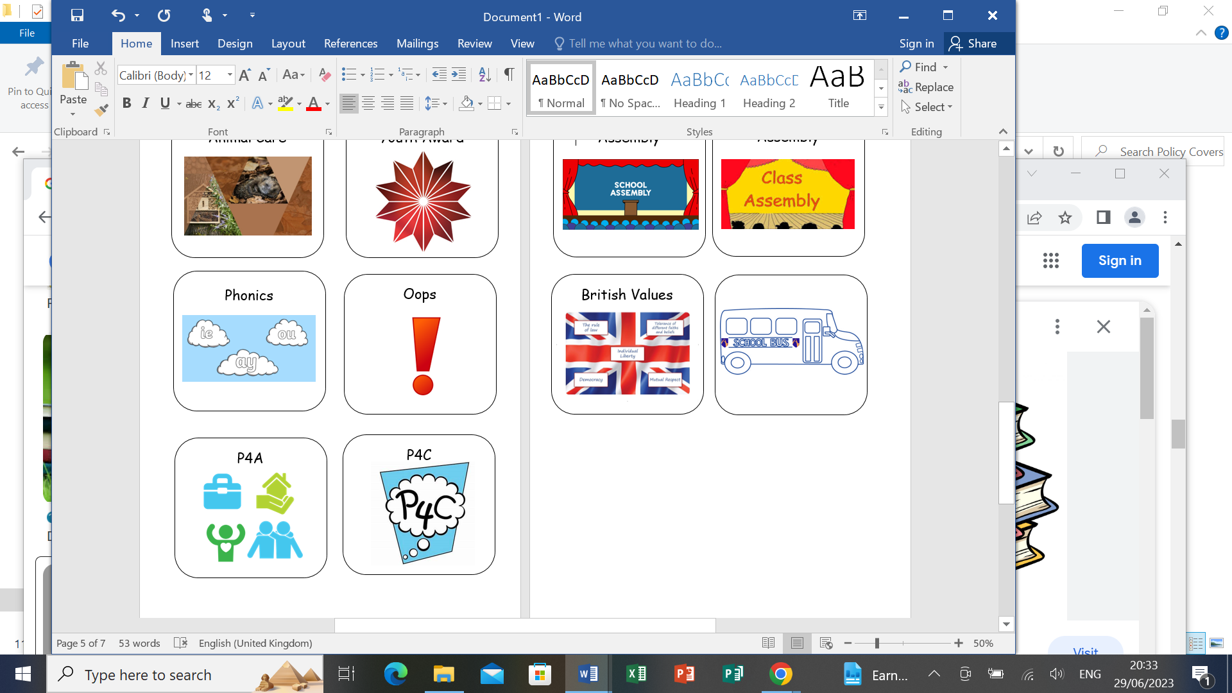  P4A |  | P4A | P4A |  | Numeracy  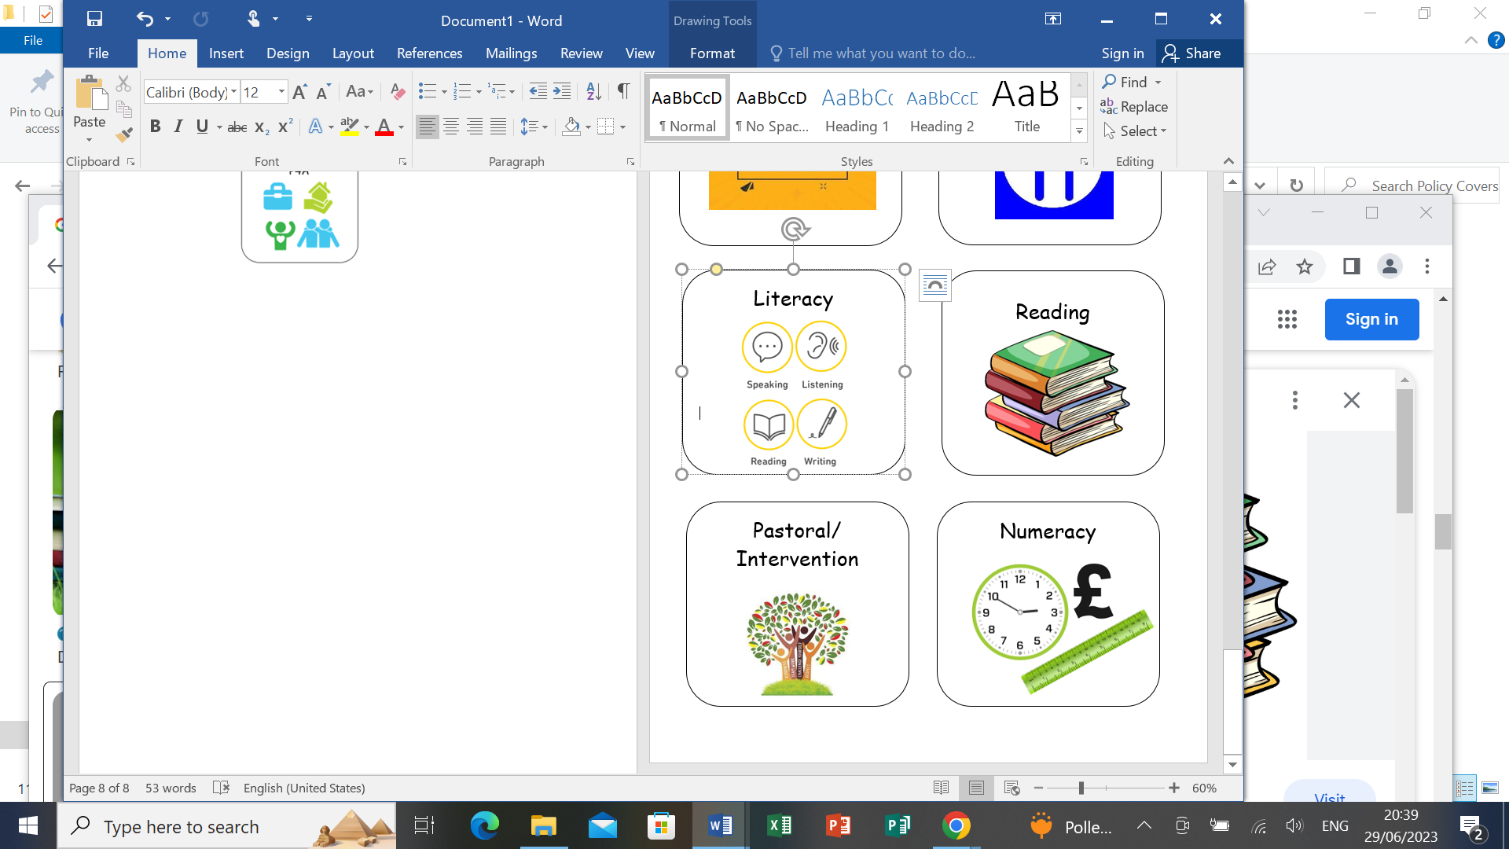 |   ACare/Hosp/Ups | ACare/Hosp/Ups
Tuesday | Literacy   |   P.E |  | P.E |   Maths |  | Current affairs   | ICT   |   B&V
Wednesday | Numeracy | Ft/Dt/CStudies     |  | Ft/Dt/CStudies |   English |  | Literacy | Maths | BTec/Voc
Thursday | Literacy | English |  | Maths | ICT |  | Numeracy |   Science |   Humanities
Friday |   Pastoral | Btec/Voc |  | Humanities | English |  | Pastoral Credits | Science  

